Tatiana Ensslin

CSE 581

**Lab 4: More Advanced Selects**

**Steps:**

1. List all company names and number of orders they placed, for companies that placed 5 or more orders.

SELECT CustomerID, COUNT(CustomerID)

FROM Orders

GROUP BY CustomerID

HAVING COUNT(CustomerID) > 5;

1. List all employees (names and IDs only) and their corresponding managers (names only).

SELECT a.EmployeeID, a.LastName, a.FirstName, b.FirstName, b.LastName

FROM Employees as a

LEFT JOIN Employees as b

ON a.EmployeeID = b.ReportsTo;

1. 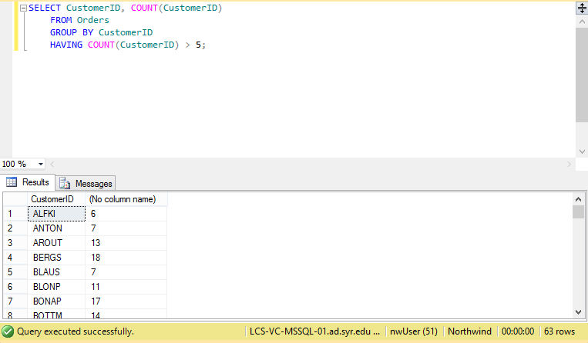

2.